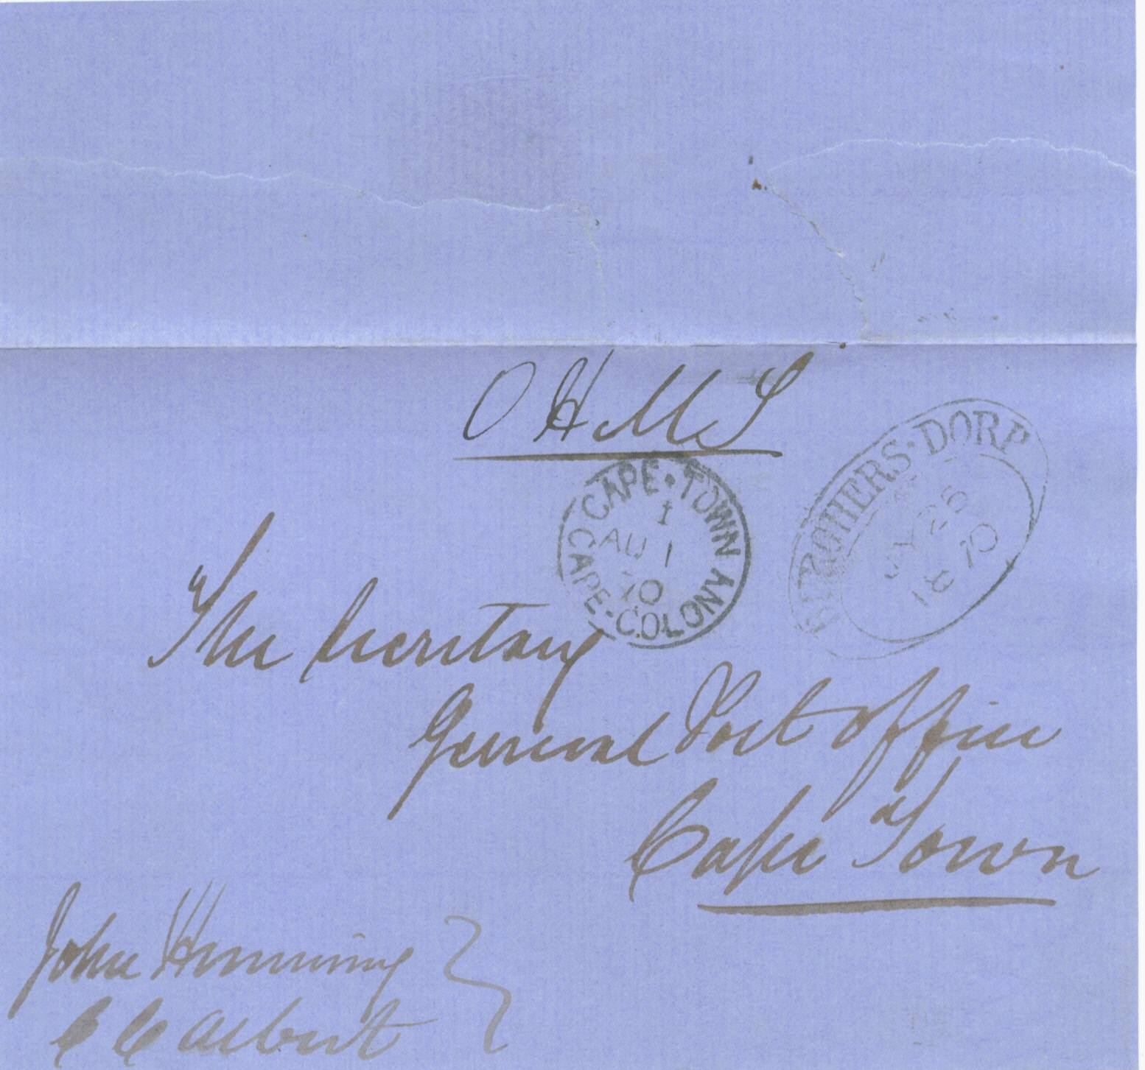
+

BURGERS-DORP TOWN OVAL HANDSTAMP

1870 on H M Service pale blue outer letter sheet, from the Burgers-Dorp post office, showing a fine black strike of the “Burgers-Dorp D.T.O.” of 26th July 1870. Letter sheet is signed by the postmaster John Heninng. Unique letter sheet recording Mr J Henning as postmaster of Burgers-Dorp at the time..

CAPE OF GOOD HOPE

DEVELOPENT OF POSTAL SERVICES

The Dated Town Oval

Handstamps of 1853

